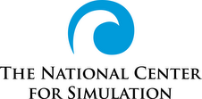

EDUCATION AND WORKFORCE DEVELOPMENT COMMITTEE
MEETING MINUTES
11 October 2017
ATTENDEES
Michelle Berggren (OCPS), Dr. Jeff Bindell (stemCONNECT), Bryon Durias (SCPS), Demetria Faison (SCPS), Dr. Bill Gaught (SSC), Dr. Steve Gordon (GTRI), Jasmine Hoegh (OCPS), Alex Kane (OCPS), Kelsey Kerce (Playground City), Jares Locke (TCHS), Alan Lynch (OCPS), Dani McNeely (NAWCTSD), Brandi Moore-Danawa (Cubic), Dr. Kristy Murray (Summit), N.Y. Nathiri (ZORA PEC),Hank Okraski (NCS), Jordan Rodriguez (Rock Lake MS), Deborah Russell (NAWCTSD), Zari St. Jean (Zora PEC), David Scott (Lockheed-Martin) Wes Shaffer (Playground City), Lindsey Spalding (SCPS), Matt Thompson (Cole Eng.), Dr. Michelle Viens (Halldale)

Agenda is provided as Attachment A.

Meeting minutes and presentations will be posted on the NCS website:

www.simulationinformation.com

ACTIVITIES AND DISCUSSIONS:

- Welcoming

Hank Okraski welcomed the committee members to the meeting held in Partnership III Building in the Central Florida Research Park. Attendees introduced themselves.

- Status of Ed&WD Committee Activities-

Hank Okraski, Committee Chairman, reported on the most recent activities of the committee. They are summarized as follows:

- Hiring M&S Interns campaign underway. Need help from industry to hire these outstanding students who have passed the NCS M&S Certification Examination. NCS is kicking-off a campaign to hire these talented students..
- M&S-Certified students seeking internships now posted on NCS website. The students’ resumes will be posted for those 18 years old or older.
- Certified teachers (24) recognized on NCS website and I/ITSEC. These teachers were given I/ITSEC VIP passes and their names will be displayed at I/ITSEC.
- Participating on Seminole State College proposal team for Florida Job Growth Grant , (See briefing by Bill Gaught Attachment D )
- Participating in Zora! STEM planning for January event. Student attendance to double at OTC(MFC)
- Working with Timber Creek HS and Hungerford ES- Timber Creek has developed a flight simulator using the Lockheed-Martin Prepar3D simulator software. The next step is to build a cockpit around the Prepar3D. The PLTW students plan to design a cockpit that will be built by Orange Technical College and integrated back at Timber Creek HS
- Participated in Advisory Boards for Orange Technical College campuses.
- History of Simulation presented to Boys/Girls Club via stemCONNECT on 11 July 2017. stemCONNECT is a very unique delivery system to bring live presentations/tours into the classrooms across the state. It is supported by the Florida High technology Council.
- History of Simulation given at Winter Park Towers on 17 July 2017
- Engaged in I/ITSEC STEM Planning. Hagerty HS students to occupy NCS booth(STEM Pavilion). DiSTI and NCS sponsors.Booth number is 2787.
- Submitted Fellow paper for I/ITSEC: Remembrances of a Simulationist.
- Presented Wonderful World of Simulation to 3 classes at Hagerty High School.
- Planning meetings underway for June 2018 Teaching the Teacher Training. Training for 40 STEM/M&S teachers planned for June 2018. The two venues are Lockheed-Martin and the Mid-Florida Campus of Orange Technical College. Lindsey Spalding, Hagerty HS, will be the lead teacher.
- Florida DoEd conducting 3-year review of M&S Secondary Course Standards. NCS six member review team identified. Review will take place on November 6, 2017 at Hagerty HS. Only the secondary education framework and standards will be reviewed.

- Teaching the Teacher Summer Training Workshop

Lindsey Spalding and Hank Okraski described the plans to date. The workshop will be a 4 day event, held 11-14 June 2017. It will be more hands-on than the prior workshop with demonstrations that reflect the State Standards. Teachers will develop lesson plans to share on the NCS website and take back to class. Teachers will be given the opportunity to take the NCS M&S Certification Examination at no charge.

D. Seminole County and Hagerty High School M&S Implementation Status

Lindsey Spalding, Lead M&S Teacher at Hagerty High School, reported on progress and program growth in implementing the new Modeling & Simulation curriculum. (Attachment B).

- Hiring M&S Interns-an Industry Perspective

Matt Thompson briefed on the success they are having with the high school interns brought on-board at Cole Engineering.( Attachment C ).

- New Seminole State College M&S Programs

Dr. Bill Gaught, Seminole State College, reported on the plans for two new simulation programs:1) a two year technician program and 2) a four year technology degree-both with simulation tracks. (Attachment D ).

- Education and Careers in Commercial Aviation

Dr. Michelle Vien, Halldale, described the current and future positions available and not being filled in the commercial aviation industry These jobs included a wide range of skills-aircrew through aviation mechanics. She described plans for a SECA Student Experience to be held on 19 April at the Rosen Shingle Creek Resort. (Attachment E ).

- Orange Technical College (OTC) and Winter Park High School M&S Implementation

Michelle Berggren, OCPS, and Alan Lynch (OTC) briefed the group on the progress at both schools. Winter Park will be standing up a full M&S curriculum. Considerable progress is being made at the MFC Launch Site with student enrollment. (Attachment F).

- Hungerford Elementary School Revitalization

Letecia Foster, Principal at Hungerford, mentioned that it appears the “new” Hungerford will not be a STEM school but will have STEM components included. She underscored the fact that the Lockheed-Martin Prepar3d Simulators will be incorporated into the courseware. The new building construction in Eatonville is progressing.

- Timber Creek/ Lockheed Martin Aviation Program

Alex Kane ,TCHS, reported on the Timber Creek Aviation initiative where the students are building a flight simulator using the Prepar3d Simulator. (Attachment G ).

- New Business

N.Y. Nathiri, PEC, announced the 29th Annual Zora Neal Hurston Festival to be held 20-28 January 2018. Integral to the festival is the Zora!STEM conference for middle school students. The program needs support to include volunteers. (Attachment H)

ATTACHMENT A

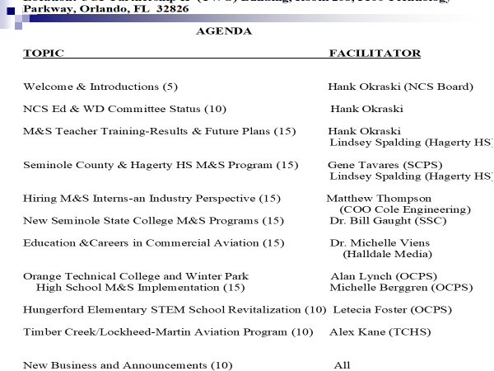

ATTACHMENT G

