NCMA
MID FLORIDA CHAPTER

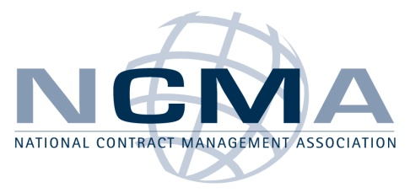

DATE: Tuesday January 19th 2010

TOPIC: EXPORT COMPLIANCE FOR ACQUISITION PROFESSIONALS
PRESENTED BY: Mr. Wayne Ferguson; Contracts Manager
Export Compliance/Technology Control Officer – CAE USA Inc.
TIME: Registration/Sign in: begins at 5:30 pm
Presentation starts at 6:00 pm
Refreshments will be provided

WHERE: KAEGAN Corporation
12000 Research Parkway, Suite 164
Orlando, FL 32826
(From Alafaya – Research Pkwy; first office building on the right/ behind the Bank of America)

Please join us for an evening of networking and a presentation by our guest speaker Mr. Wayne Ferguson; Manager of Contracts and the Export Compliance/Technology Control Officer for CAE USA Inc.

Wayne has over thirty years experience in government and commercial contracting and management. Wayne has held both industry and Government positions as a Contracting Officer and Supervisor at Aeronautical Systems Center, Wright-Patterson Air Force Base, OH and in contracts/subcontracts management in industry. He has over ten (10) years experience in the export compliance field. He established and maintains the company Export Compliance Program website for CAE USA.

Wayne has a Bachelor of Science in Industrial Management, as well as, a Master of Business Administration received from Wright State University. He has completed numerous acquisition management and export compliance courses.

RECOGNITIONS/MEMBERSHIPS

- Professional Designation in Contract Management from the Air Force Institute of Technology (AFIT)/ NCMA.
- Long time member of NCMA.
- Member Society for International Affairs (SIA) – eminent organization of export professionals

The price of the event is $20 for NCMA Members and $25 for non-members, cash or checks (made payable to NCMA mid Florida Chapter) will be accepted at the door.
- Refreshments will be provided
- Bring your business card for a chance to win a door prize
- There will be an additional chance to win a prize with purchase of Raffle tickets (each ticket just $1)!

For planning purposes please RSVP by email to tomhigh@kaegan.com NO LATER THAN January 12th, 2010 with number and names of attendees.

