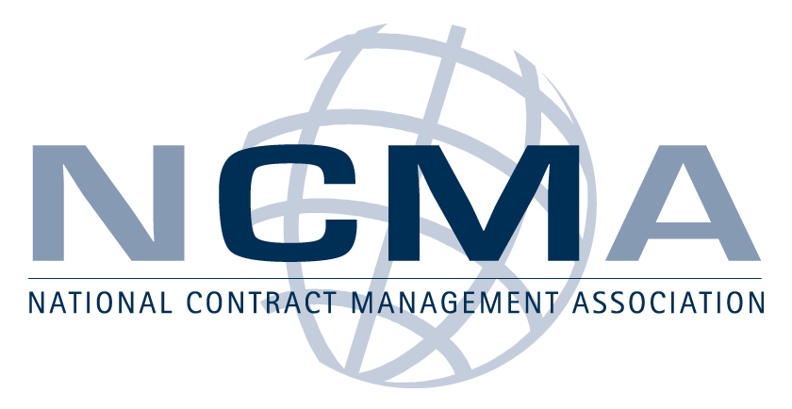
NCMA Mid Florida Chapter
Contracting News | Volume #2 | December, 2009

DATE: Tuesday January 19th 2010

TOPIC: EXPORT COMPLIANCE FOR ACQUISITION PROFESSIONALS
PRESENTED BY: Mr. Wayne Ferguson; Contracts Manager
Export Compliance/Technology Control Officer – CAE USA Inc.
TIME: Registration/Sign in: begins at 5:30 pm
Presentation starts at 6:00 pm
Refreshments will be provided

WHERE: KAEGAN Corporation
12000 Research Parkway, Suite 164
Orlando, FL 32826
(From Alafaya – Research Pkwy; first office building on the right/ behind the Bank of America)

Please join us for an evening of networking and a presentation by our guest speaker Mr. Wayne Ferguson; Manager of Contracts and the Export Compliance/Technology Control Officer for CAE USA Inc.

Wayne has over thirty years experience in government and commercial contracting and management. Wayne has held both industry and Government positions as a Contracting Officer and Supervisor at Aeronautical Systems Center, Wright-Patterson Air Force Base, OH and in contracts/subcontracts management in industry. He has over ten (10) years experience in the export compliance field. He established and maintains the company Export Compliance Program website for CAE USA.

Wayne has a Bachelor of Science in Industrial Management, as well as, a Master of Business Administration received from Wright State University. He has completed numerous acquisition management and export compliance courses.

RECOGNITIONS/MEMBERSHIPS

- Professional Designation in Contract Management from the Air Force Institute of Technology (AFIT)/ NCMA.
- Long time member of NCMA.
- Member Society for International Affairs (SIA) – eminent organization of export professionals

The price of the event is $20 for NCMA Members and $25 for non-members, cash or checks (made payable to NCMA mid Florida Chapter) will be accepted at the door.
- Refreshments will be provided
- Bring your business card for a chance to win a door prize
- There will be an additional chance to win a prize with purchase of Raffle tickets (each ticket just $1)!
For planning purposes please RSVP by email to tomhigh@kaegan.com NO LATER THAN January 12th, 2010 with number and names of attendees.
President’s Message:
I want to take this opportunity to again thank Audrey Fogelman, Mr. Steve Hopkins from CAE USA Inc., Professional Services Division and Mr. Joe Giunta, Jr., Director, Acquisition Center/Principal Asst. Responsible for Contracting (PARC) US Army, PEO STRI for a very informative and enjoyable presentation on ‘PEO Hot Topics Driving Change’. These are definitely challenging economic times for both industry and the US Government as we work our way through the future economic and political landscape. We had 50+ people attend the workshop including several UCF students who are developing the Charter and goals for our UCF NCMA student chapter and internship program.
During our Executive Council Meeting December 10th, the UCF outreach committee agreed to present the UCF NCMA Student Chapter By-Laws, Charter Member list, Student Government Association Guidelines for Student Associations at the January Council meeting. The Committee will also be meeting with Denise Moore, MA, Faculty Undergraduate Studies UCF Career Services & Experiential Learning and Dr. Cameron Ford, Director of the Center for Entrepreneurship and Innovation to discuss the possibility of setting up a contract administration internship program and the Mid Florida Chapter’s intentions to submit the charter for a UCF NCMA Student Chapter. Both of these individuals have been very supportive of our efforts to start a student NCMA chapter at UCF.
The goal of the UCF Outreach program is to introduce students to opportunities that are available in the field of contract management and provide a basic introduction to the various federal and state agencies acquisition processes, as well as increase their understanding of the hiring process. UCF has several different intern/COOP programs which provide credits and other incentives for students who work part time. We are looking for volunteers interested in mentoring UCF students in learning more about the field of contract management and developing some basic contract administration workshops to be offered in the evenings to members of the student outreach program/UCF NCMA Student Chapter. If you would be interested in learning more about the UCF Outreach program please contact Jeff Stingle or Ken Meyer.
Finally as we enter the New Year the Executive Counsel and Committee members would like to wish everyone a very peaceful and Happy Holiday season and a healthy and prosperous New Year. See you in 2010.

Open Letter to Government Employees: Becoming Engaged with NCMA Enhances Professionalism and Mission Success
December 3, 2009
Open Letter to Government Employees
Becoming Engaged with NCMA Enhances Professionalism and Mission Success
November 7, 2009
For over 50 years, NCMA has led and represented the contracting profession. The association currently has over 19,000 members and has operating chapters across the United States and in more than 13 countries. However, NCMA's biggest value is in the day-to-day practice of contract management. NCMA provides a collection of neutral networks or communities, at the local and national level, where contract management professionals from all types of government and industry agencies and organizations can come together with a common goal: To enhance their professional expertise in a non-adversarial environment, thus enabling them to more effectively accomplish the mission of their organizations.
The strength and uniqueness of NCMA comes from its ability to provide this neutral environment where professionals from government and industry can come together to discuss, analyze, and advance the state of the contract management profession. During the last two years, this strength of the association has been affected in some instances by officials who have looked at available ethical guidance, which is limited and in some cases contradictory, and concluded that contracting personnel in their agency or office should err on the side of caution and not be an active participant in NCMA activities. Some of this advice has prevented government contracting professionals from acting as local NCMA chapter officers or even active volunteers, (e.g. meeting coordinator). Some advice has also prohibited government contracting professionals from participating at the national level as members of the Board of Directors or the Executive Advisory Committee. Fortunately, such advice is not the norm across the country, and we are unaware of any government employee being advised that membership in NCMA in an unofficial capacity is prohibited.
In most government agencies, advisors faced with the same set of facts briefly outlined in the previous paragraph have concluded that such activity on the part of government contracting professionals is acceptable, provided certain rules are followed. In order to bring some consistency to this issue, NCMA approached the Office of Government Ethics and proposed a set of principles that would be generally applicable to all government professionals. The guidelines we proposed were drawn from and modeled after the DOD's Joint Ethics Regulation.
OGE responded to our request on April 30, 2009, and generally agreed with our guidelines. In their letter, OGE stated, "As a general matter, this list indicates a good understanding of the Standards of Conduct applicable to executive branch personnel and the ethical principles that underlie the standards." However, OGE went on to say that there may indeed be circumstances where it would be wise for individual employees to seek legal advice regarding unique circumstances applicable to their particular professional responsibilities.
Because of the large number of DOD employees involved with NCMA activities, OGE suggested we obtain a review of our guidelines by the DOD director of standards of conduct (SOCO). While that office does not issue official advisory opinions to organizations such as NCMA, SOCO provided us with additional clarifying information on October 1, 2009 that has been incorporated into the following guidelines.
The guidelines we proposed are as follows:
Activities allowed for federal employees in a personal capacity:
- Become members of NCMA acting exclusively outside the scope of their official position.
- Attend and participate in educational NCMA conferences, workshops, or meetings if approved in accordance with agency procedures. See item #7 in this list for additional guidance.
- Participate in the management of NCMA (Board of Directors) at the local or national level in a personal capacity acting exclusively outside the scope of their official position, provided they are invited to participate in such a position because of their expertise or years of experience and not because of their current job or position. The listing of board members will not include the government member's official title; however, the name of the organization is acceptable. When participating in a board meeting during normal duty hours the federal employee should normally take leave. Board members at the local or national level may not receive compensation for participation in board business, but they may receive reimbursement of actual expenses in accordance with the rules of the specific board involved. If an employee because of his or her government position is required to file a financial disclosure statement, (e.g. SF form 278 or OGE form 450), the employee must report any position held in NCMA on that form.
- Present an educational briefing to an NCMA conference, workshop, or meeting in their official position in order to present information about current activities in their service or agency. See item #7 in this list for additional guidance.
- Participate on the NCMA Executive Advisory Council in nonmanagement, nonfiduciary roles, in a personal capacity acting exclusively outside the scope of their official position, provided they are invited to participate in such a position because of their expertise or years of experience and not because of their current job or position.
- Limited use of government e-mail for simple communications (not a statement of promotion or endorsement) to forward announcements of NCMA educational events since such announcements serve the common interests of government acquisition professionals in a manner that is consistent with DOD Joint Ethics Regulation paragraph 3-208. In this regard, NCMA has been advised by the DOD Standards of Conduct Office that the chief of the contracting office, or similar government official, should be advised of the nature of such communications and asked to approve the use of government e-mail for this purpose. Such approval should be sought on an annual basis or more frequently if desired by the activity's approving official. Obtaining coordination and approval to use government e-mail systems to announce NCMA program activities is considered a prudent step for non-DOD activities as well.
- Accept cash awards under awards programs administered by NCMA unless the awardee's official position could substantially affect the interests of NCMA. The award may include free attendance at the event, including education conferences and gala awards ceremonies, as well as travel expenses to the event for themselves and their families. In general, such awards are acceptable because NCMA makes awards pursuant to published and public criteria and never includes consideration of a potential awardee's official position as a criterion. Under some circumstances, (e.g. the award is valued at in excess of $200), the employee who is to receive the award may require specific a written determination from his or her agency ethics official to confirm these circumstances.
- Organizations and commands may provide logistical support (provide government facilities, pay travel expenses to participants or speakers, etc.) for NCMA events because such events are structured to serve DOD public interests (neutral forum to discuss and learn about professional and related material), not interfere with government official duties, and charge a reasonable fee to each participant. (A "reasonable fee" is generally defined as less than or equal to $645 per day in FY 2009 economics.)
Activities not allowed for federal employees in a personal capacity:
- Use their official position to direct subordinates to become an NCMA member or participate in NCMA events.
- While serving as a national or local board member or officer, make a decision in their official government capacity that would further the purposes of NCMA. If the individual would normally be asked to act on such a request because of their official position, (e.g. approve use of government facilities for a meeting), the individual will defer the decision to an appropriate person in the management structure.
- Use their official government position to directly further the purposes of NCMA, (e.g. sending out a communication specifically advocating an NCMA event).
- Accept a cash award if the employee in their official position could substantially affect the interests of NCMA.
We believe these guidelines serve as a framework within which government employees in all agencies and at all levels can safely and ethically participate in NCMA activities. However, in accordance with OGE's caution, we encourage individuals to seek local legal advice regarding any unique circumstances or for individual guidance in applying these guidelines.

Signed,
NCMA Board of Directors
Please direct inquiries about this letter to
Neal Couture, CPCM, Executive Director
ncouture@ncmahq.org
____________________________________________________________________________________
Current Mid-Florida Chapter Executive Committee members are:
President: Kenneth.meyer@dcma.mil. Ph: 407-823-8409 ext 21
VP/Programs: Jeffrey.j.stingle@lmco.com Ph: 407-306-2404
VP/Education: Tomhigh@KAEGAN.com Ph: 407.363.3636
Secretary: Audrey Fogelman: Audrey.fogelman@cae.com Ph: 407.739.1619
Dir of Communication: Nikki White: nikki.white@astronics.com Ph: 407.531.7476
Treasurer: Ed McCann; edward.t.mccann@lmco.com Ph: 407. 356. 8092
Please check out our local web site at http://intranet.ncmahq.org/midflorida/default.aspx. referencing LINKS for several job openings. If you know of any job openings please contact one of our committee members and we will gladly post them.

UPCOMING EVENTS:
Jan 7 2009 | Annual Defense Forum Breakfast. See flyer for more details | Sponsored by: CPAG | Presented by: Dr. Jim Blake, PEO STRI; CAPT Harry Robinson, NAWCTSD; COL David Smith, PM TRASYS; COL (S) Marcus Boyd, USAF
Jan 2010 | EXPORT COMPLIANCE FOR ACQUISITION PERSONNEL | Sponsored by: Kaegan | Presented by: Wayne Ferguson; Contracts Manager and Export Compliance Officer, CAE USA Inc.
Jan 22-23 | Mid Year Leadership Conference Las Vegas, NV | Sponsored by: NCMA HQ | More information at http://ncmahq.org
Feb 2010 | BRIDGING THE GAP BETWEEN GOVERNMENT AND INDUSTRY | Sponsored by: Astronics DME | Presented by: A panel of Government Representatives & Industry Representatives
March 24-26 | Keys to Negotiating Better Software Agreements | Sponsored by: Budd Larner Software | The Hilton at Walt Disney World 1751 Hotel Plaza Blvd. Lake Buena Vista, FL Software Seminar brochure
March  TBD | The New Government Contracting Environment | Sponsored by: NCMA Bank of America, Merrill Lynch | A panel of Government & Industry Representatives.

Additionally, if there are any topics you would like to hear about please contact one of the committee members.

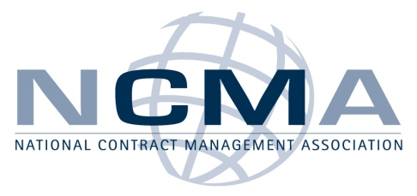

- The embedded file below contains information for the January 7, 2010 Defense Forum Breakfast held at the Radisson University hotel.

