Event Description 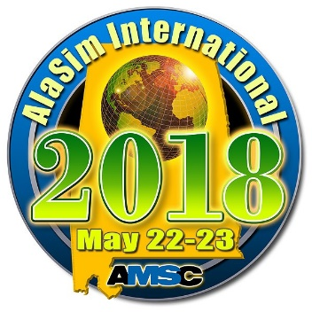
The annual AlaSim International Conference & Exposition will be held at the Holiday Inn Research Park in Huntsville, AL May 22 -23, 2018. This M&S event showcases the vibrant, multi-domain, modeling and simulation (M&S) industry in Alabama. The conference is designed to focus on both the breadth and depth of simulation activity in Alabama and to collect, document, display, and discuss the current state of simulation technology throughout the world.
The AlaSim conference program typically includes plenary speakers, paper presentations, project briefings, panel discussions, workshops, tutorials, and vendor exhibits displaying the latest simulation technology, products, and services.
The AlaSim Conference offers a variety of opportunities for M&S practitioners, vendors of M&S products and services, M&S academia, and many others. It is the ultimate venue to see and be seen; hear and be heard; to instruct as well as to learn about the science, technology, and business of modeling and simulation.
- Speakers: Plenary speakers and industry experts will present project and program briefings about simulation work planned and in-progress throughout the conference.
- Panel Discussions: Opportunities for open discussion with M&S subject experts.
AlaSim Session Attendees
Workshops: An open and collaborative environment for the definition and creation of modeling and simulation products.
- Tutorials: To provide introductory and advanced training in current simulation technology.
- Exhibit Area: Where industry exhibitors will be displaying their latest simulation products and capabilities.
- Sponsorship Opportunities: Opportunities for sponsors to promote their products, message, and/or brand.
AlaSim International is organized by the Alabama Modeling and Simulation Council.

