Office of the National Ombudsman
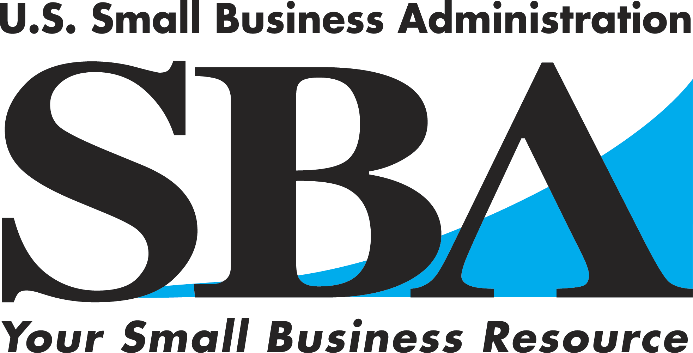

Regulatory Fairness Forum for Small Business

Thursday, October 28, 2010
Orlando, Florida
Small business owners will have an opportunity to discuss issues regarding Federal regulatory compliance and enforcement during this Forum.
Have you or a small business owner you know been unfairly fined or penalized by a Federal
government agency, or is a Federal agency enforcement action imminent?

WHO: SBA National Ombudsman Esther H. Vassar will meet with members of the Orlando area small business community to hear issues and comments about federal regulatory enforcement and compliance actions. Small business owners, representatives of trade associations and community and business leaders are invited to participate, comment about compliance actions and enforcement of regulations by federal agencies and learn more about the impact of federal regulations on small businesses.

WHAT: To create a more cooperative regulatory environment among federal agencies and small businesses, Congress has directed the SBA and the National Ombudsman to hold Regulatory Fairness forums for small businesses. The National Ombudsman will direct any specific issues addressed at this forum to the appropriate Federal agency for a higher-level review of fairness of the enforcement action. In many instances, the National Ombudsman’s action has resulted in federal agencies reducing or waiving penalties and/or compliance actions in cases of unfair or excessive regulatory enforcement.

WHERE: The Disney Entrepreneur Center
315 East Robinson Street
Suite 100
Orlando, Florida 32801

WHEN: Thursday, October 28, 2010
9:30 a.m. – 11:00 a.m.

Members of the small business community, trade organizations and media are encouraged to attend. RSVPs should be made to Lola Kress of the SBA North Florida District Office at (904) 443-1933 or by email to lola.kress@sba.gov before the forum. Space is limited. Small business owners or representatives unable to attend can contact the National Ombudsman for further assistance.
For additional information, visit the Office of the National Ombudsman’s website at
www.sba.gov/ombudsman.

 
All of the SBA’s programs and services are provided to the public on a nondiscriminatory basis. Reasonable arrangements for persons with disabilities will be made, if requested at least 2 weeks in advance. Contact: lola.kress@sba.gov.

