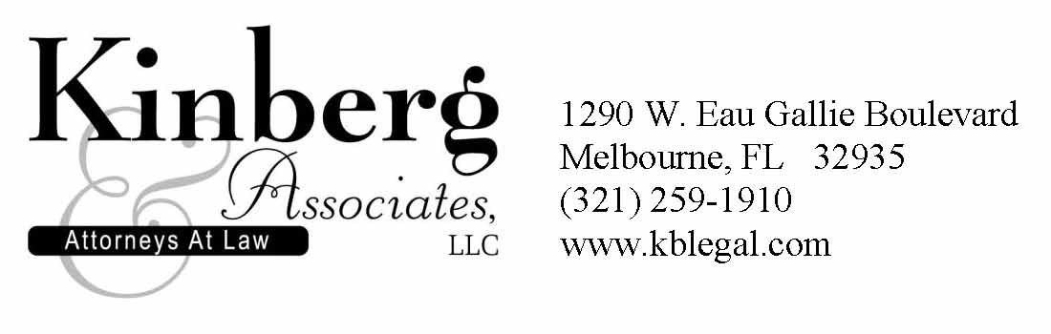


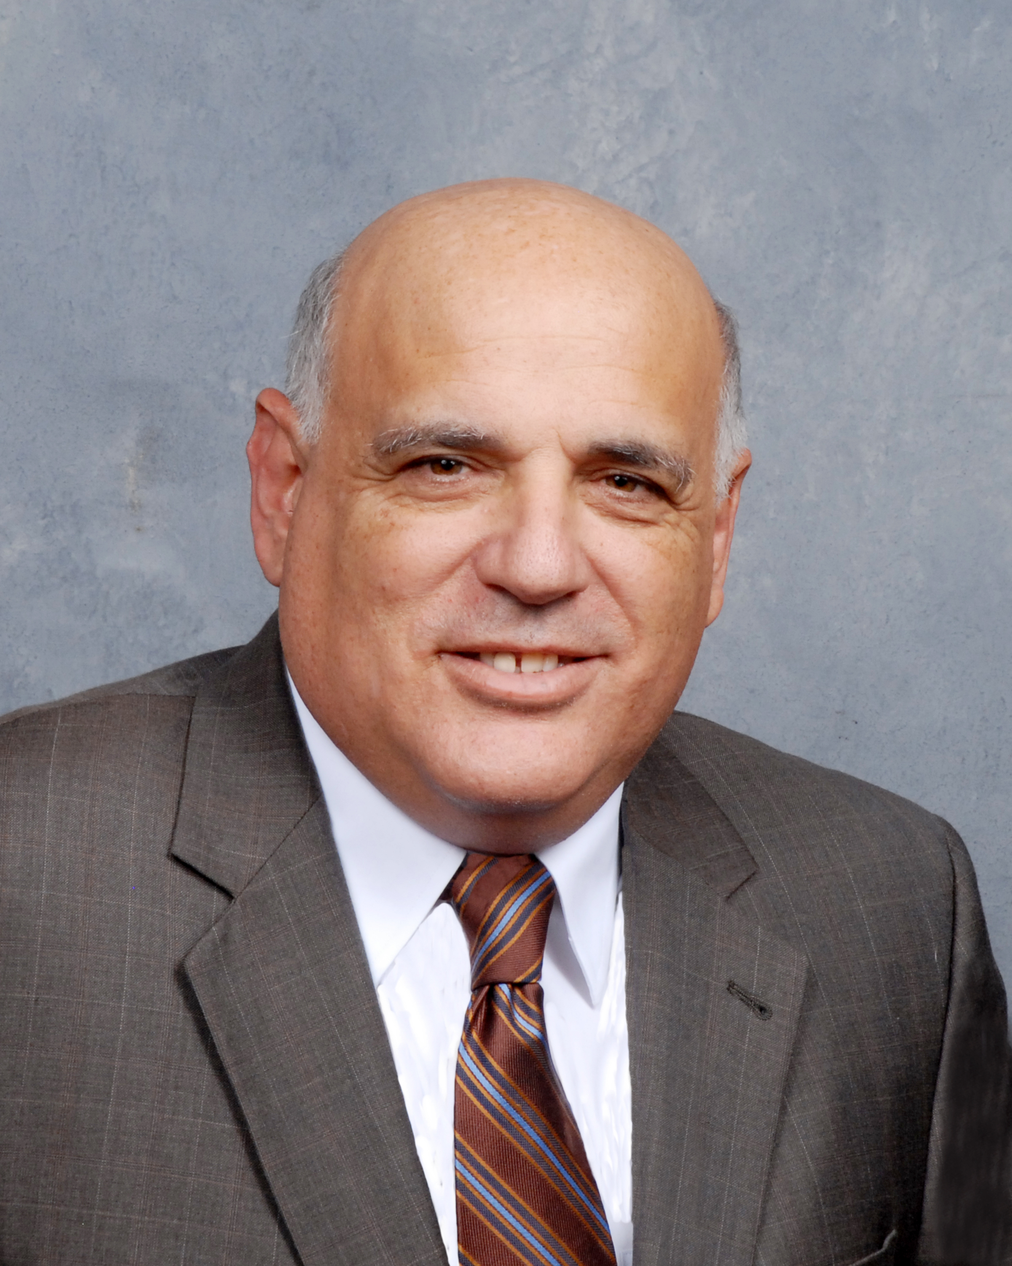
Edward J. Kinberg
Attorney
Federal Procurement Law
Fellow, National Contract Management Association
Mr. Kinberg represents many clients with government contract disputes and bid protests. He assists clients with issues involving contract formation, interpreting terms and conditions, preparing and submitting claims and litigating complex disputes before Federal and State Courts, Boards of Contract Appeals and the Government Accountability Office (GAO).

Prior to opening his law firm in 1996, Mr. Kinberg served as an attorney with the US Army Judge Advocate General’s Corps (JAG).
Join the National Center for Simulation and
Attorney Ed Kinberg for
an informal discussion about Teaming Agreements

February 8, 2012
8:00am – 9:30am

Research Park, Partnership II, Room 209
3100 Technology Parkway
Orlando, FL 32826

Mr. Kinberg, a Fellow of the National Contract Management Association (NCMA) will lead an informal roundtable discussion related to Teaming Agreements in Government Contracting. The discussion will be focused on the concerns and interests of those attending.

If you are able to join us, please RSVP to Carla Hoskins @
choskins@simulationinformation.com or 407-384-6111

