FOR IMMEDIATE RELEASE

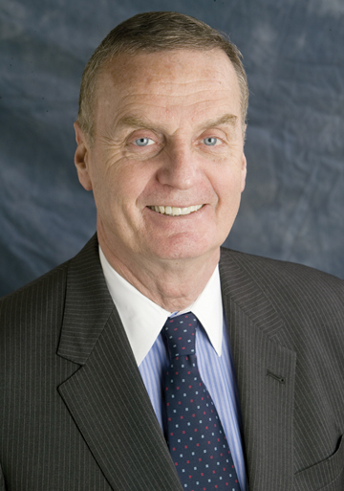

Former National Security Advisor, General James L. Jones, USMC (Ret.)
To Address Veterans and Public on National Security in Our Time

ORLANDO, Fla. - (October 6, 2011) James L. Jones, General, USMC (Ret.), will discuss National Security in Our Time in an address to Central Florida Veterans and the public on Thursday, October 20 at 1:30 p.m. at the American Legion State Headquarters 1912A Lee Road in Orlando. General Jones is speaking at the invitation of the Central Florida Veterans Memorial Park Foundation which is conducting a capital campaign to construct and endow a Memorial at Lake Nona next to the VA Hospital to honor over 1,000 of the Fallen, who served in the uniform of our country, made the ultimate sacrifice and did not return, according to Jerry E. Pierce Board Chair. Veterans and the general public are invited to attend at no charge.

1

"The defense of our country is of great concern to all Americans," according to Jay M. Garner, Lieutenant General, Retired US Army of Windermere and Honorary Chair of the Memorial Park campaign. " I am delighted that General Jones is taking time from his demanding consulting and speaking schedule to come to Central Florida and discuss national security in our time," said Garner.
During his military career, General Jones served as Commander, United States European Command and Supreme Allied Commander Europe. He served his country for 40 years in the US Marine Corps and from July of 1999 to January of 2003 as the 32nd Commandant of the Marine Corps. After retirement General Jones served as our country's 22nd National Security Advisor and remained involved in national security and foreign policy issues, including the chairing of a Congressional Independent Commission on the Security Forces of Iraq.

Attendance to this event is free and open to the public. Attendees are asked to RSVP by calling Rachel Castleberry at 407-295-2631, Ext 231 or Mary Ricci at Ext 232 or emailing Jerry@REWonline.com. Refreshments will be provided.

Contact: Jerry Pierce
Central Florida Veterans Memorial Park Foundation, Inc.
jerry@rewonline.com, 407/529-6925

# # #

2

